www.swkp.org.uk
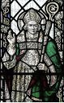

St. Wilfrid's Cottage 97 Lorrimore Road, Kennington Park. SE17 – 3LZ 0207 358 4259

Fr. Vincent Flynn Parish Priest: stwilfrids97@gmail.com Rev. John Greenwood: WJohngreenwood@aol.com
Christus Vincit SVP FOR THOSE IN PHYSICAL OR SPIRITUAL NEED: 077192 44351 stwilfridssvp@gmail.com
Please Support Our Building & Restoration Project

All of the money raised in the second collection goes towards the restoration of our beautiful Church.

The beautiful stonework around the upper windows is slowly being restored. A seal is being applied around the windows to prevent future water penetration. Plaster, which has blown, is being removed; a water sealant will be applied before re-plastering.

On 23 October we will begin to rewire the Church and fit new lights (£20,000), with proper circuit breakers. This will be a somewhat lengthy process as the electrician has other commitments. Much of the wiring is incredibly old with areas having not been earthed.

National Shrine of St. Jude

Saturday 28 October 2pm – 4.00pm
Faversham, ME13 - 7JW
The national shrine, based in our diocese, will celebrate the feast with Mass and the blessing of oil and anointing. A nice day out and an opportunity to meet the Carmelite Friars.

Extraordinary Lives
Extraordinary Saints

An inspirational one-day conference
for Catholics working in healthcare

4 November 12pm – 6pm
St. Aloysius Church Euston

www.CatholicMedicalAssociation.org.uk

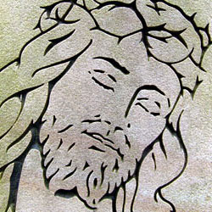

Thank you for last Sunday's Collection
1st £458 Building £339
God is never outdone in generosity!

So that the Lord's work might continue,
please consider leaving a legacy to
St. Wilfrid's.

I

CHOSE

YOU

TO

BEAR

FRU
I
T
8 October 2017 (A)

7th Saturday 4.30pm Confessions
First Mass of Sunday 5.00pm Mass Dorothy Parks
8th Sunday 9.30am Rosary
9.30am Confessions
Twenty-Seventh 10.00am Mass Peter, Theresa & baby Theresa
PRISONERS’ SUNDAY + Children's Liturgy
11.00am Tea & Coffee
11.30am Confessions
12.00pm (Noon) Mass People of the Parish
9th Monday 9.30am Rosary
Blessed John Henry 10.00am Mass Maxine O’Reilly & family tree
Newman 10.20am Tea & Coffee
10th Tuesday 9.30am Rosary
St. Paulinus 10.00am Mass Chigbo & Family (Thanksgiving)
11th Wednesday NO MASS
12th Thursday 6.00pm Confirmation Formation
St. Wilfrid 6.00pm Exposition & Adoration
Patronal Feast 6.05pm Rosary
6.05pm Confessions
6.20pm Benediction
6.30pm Mass Clement Flynn, RIP
13th Friday 9.30am Rosary
St. Edward 10.00am Mass Ethel Larkin, RIP
the Confessor 10.20am Exposition & Adoration
Vocations to the Sacred Priesthood
10.30am Confessions
10.50am Benediction
14th Saturday 10.45am 1st Holy Communion (Church/Hall)

4.30pm Confessions
First Mass of Sunday 5.00pm Mass Mr & Mrs Parks, RIP
15th October 9.30am Rosary
Sunday 9.30am Confessions
Twenty-Eighth 10.00am Mass Hyslop Nimmo, RIP
+ Children's Liturgy
First Holy Communion Enrolment Mass
11.00am Tea & Coffee
11.30am Confessions
12.00pm Mass People of the Parish
the sanctuary lamp

is burning perpetually this week for the good health of:

Eileen Baber

Requests via the sacristy. Recommended minimum donation £10

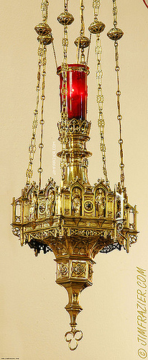

Missio

Next Sunday there will be a retiring collection for Missio, the Church’s official organ for the support of foreign missions. All of the money collected goes in its entirety to support churches, hospitals, schools and vocations in countries where the Church is new, young or poor. All resources are distributed equitably and justly on the basis of need.

